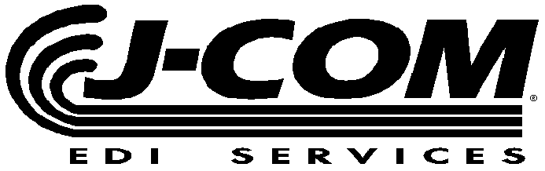
  Ph: (810) 694-8288
  Fax: (810) 694-8224
   www.j-com.com

GM SPO SHIP DIRECT ASN REQUIREMENTS

COMPANY  NAME: |  | CONTACT  NAME:
COMPANY  FAX NUMBER: |  | CONTACT  PHONE NUMBER:

* SHIPMENT IDENTIFICATION NUMBER (Packing Slip, Bill of Lading or Invoice Number) |  | Total Number of Pages for this Shipment

SHIP DATE | SHIP TIME | GROSS WEIGHT | CONTAINER QTY

CARRIER  SCAC CODE | TRAILER NUMBER | SOURCE CODE | CUSTOMER CODE

LINE ITEM # | PART NUMBER | SHIP QUANTITY | YTD CUM | CARRIER TRACKING NUMBER | SHIP DIRECT ORDER NUMBER

SPECIAL INSTRUCTIONS

