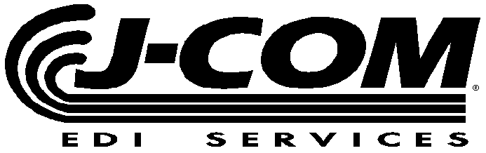
  Ph: (810) 694-8288
  Fax: (810) 694-8224
   www.j-com.com

GM ASN REQUIREMENTS

COMPANY  NAME: |  | CONTACT  NAME:
COMPANY  FAX NUMBER: |  | CONTACT  PHONE NUMBER:

* SHIPMENT IDENTIFICATION NUMBER |  | Total Number of Pages for this Shipment

* PURPOSE CODE | SHIP DATE | SHIP TIME | * GROSS WEIGHT | NUMBER OF CONTAINERS
09=SEND 01=CANCEL

PICK UP CARRIER  SCAC CODE | DELIVERY CARRIER  SCAC CODE | MODE CODE | TRAILER NUMBER | BILL OF LADING NUMBER

* Your DUNS NUMBER | ORDERED BY From DELFOR or DELJIT | * GM’s CISCO SHIP TO CODE | DOCK NUMBER

* GM Part Number | *Ship  Quantity | U/M | Year to  Date CUM | * PO Number

SPECIAL INSTRUCTIONS
* MANDATORY FIELDS

* GM Part Number | *Ship  Quantity | U/M | Year to  Date CUM | * PO Number

* GM Part Number | *Ship  Quantity | U/M | Year to  Date CUM | * PO Number

* GM Part Number | *Ship  Quantity | U/M | Year to  Date CUM | * PO Number

* GM Part Number | *Ship  Quantity | U/M | Year to  Date CUM | * PO Number

