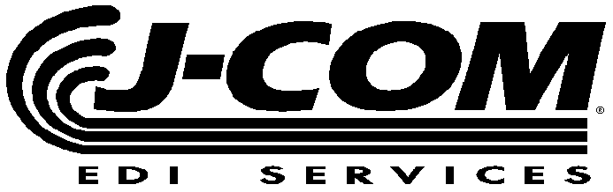
    Ph: (810) 694-8288
    Fax: (810) 694-8224
     www.j-com.com

HONDA ASN REQUIREMENTS

COMPANY  NAME: |  | CONTACT  NAME:
COMPANY  FAX NUMBER: |  | CONTACT  PHONE NUMBER:

HONDA SHIP TO
NAME

Canada, Alabama, America, Anna, E. Liberty, Marysville, Mexico

ASN NUMBER

SHIP DATE | SHIP TIME | SCAC CODE | TRAILER NUMBER | BILL OF LADING NUMBER

HONDA PLANT ID | HONDA SHIP TO CODE | SUPPLIER CODE

SPECIAL INSTRUCTIONS

LOAD TYPE

Master, Mixed or Loose Container (s)

Pallet Container ID | Bar Code Serial Number | Part Number | PO Number | ENG CHG | Quantity | U/M

